**Credit Card Approval using Machine Learning**

**Abstract:**

**Credit scorecards are a common risk control method in the financial industry. It uses personal information and data submitted by credit card applicants to predict the probability of future defaults and credit card borrowings. The bank can decide whether to issue a credit card to the applicant. Credit scores can objectively quantify the magnitude of risk. In general, credit scorecards are based on historical data. Today, due to the advancement of machine learning algorithms there are many predictions model such as Boosting, Random Forest, Logistic Regression, and Support Vector Machines have been introduced into credit card scoring. Following Business issues will be addressed in this project using the below-mentioned dataset: Build a machine learning model to predict whether an applicant is eligible for a credit card, solving an Unbalanced dataset problem, Analysing the categories important for credit card eligibility, and comparing the various machine learning algorithms and their predictions and summarizing in the end.**

1. **Introduction:**

In recent times, one of the most important transformations taking place is the shift toward digitalization. One of the sustaining areas where digitalization has become a trend is in cashless transaction activities. This has become a very prominent method and more people are inclined towards cashless transactions as this reduces the risk of misplacing physical cash. So, many financial institutions across the world are providing cashless means for their users like debit and credit cards. One of the most prominent options is having a credit card. Most people rely on credit cards to perform their transaction activities as it is a very easy way of making their payments. The private banks rely on consumer information like their basic info, living standards, salary, yearly and monthly returns, their current livelihood income source, etc. All this info is reviewed before processing the application forms with the bank. This complete check and analysis can help the banks get through the hassle of enduring the technical / non-technical losses and the loss of time to both the customers and the banks so that the concentration is more towards the productive outcomes of both parties. A proper analysis is required as we see tremendous growth in the financial sector to avoid any kind of potential risk related to the unethical consumer.

1. **Data Set description**

With the above-mentioned scope in our mind, we took an initiative with this project to analyze how financial institutions can achieve productivity by taking many variables into our account. The main objective of the project is to analyze the credit risk criteria by taking many consumer factors into the consideration. Our goal is to apply different methodologies to form a strategy that determines if a consumer is eligible for a loan. To achieve this, we have considered taking a credit risk proposal dataset from **Kaggle**: <https://www.kaggle.com/code/advaithmenon14/credit-card-approval-prediction-using-ml/data>

As mentioned before, Credit risk is associated with the possibility of a client failing to meet contractual obligations, such as mortgages, credit card debts, and other types of loans. Our datasets from Kaggle contain two files, application_record.csv containing of over 43000 rows and 18 columns, and the credit_record.csv detailing the Dependent variables. Firstly, by understanding the dependent variables given in the credit_record.csv, we could see that under the STATUS column, the **STATUS showing as 0** describes that the consumer is 1-29 days past due for the payment for their credit card. **STATUS 1** describes the consumer is 30-59 days past due the payment for their credit card. **STATUS 2** describes the consumer is 60-89 days overdue, **STATUS 3** describes 90-119 days overdue, **STATUS 4** shows 120-149 days overdue, and **STATUS 5** shows overdue or bad debts, and write-offs for more than 150 days. The **STATUS C** details about the paid off that month and **STATUS X** describes there is no loan for the month. In the **MONTHS_BALANCE** column, assuming the month of the extracted data as the starting point, the value 0 is considered to be of the current month, -1 is of the previous month, and so on.

Hence, based on the details mentioned above, our task is to implement certain methodologies and the machine learning algorithms on our Independent Variables in the application_record.csv dataset to validate how efficiently our machine learning algorithms perform in accessing the credit risk of the consumers while various factors are taken into consideration. Our assessment is done based on the IV’s such as the consumer’s gender, if they own a car, if they own a property, what is the housing type, their annual income, etc. For more details regarding each IV, please review it under the Kaggle link above.

1. **Data Pre-processing:**

As we validated the values under each IV, we could see that the dataset contained a mixture of both numerical and non-numerical features. The values are also of different ranges and the dataset had several missing values. Hence, it is a liability that the data must be pre-processed before running different machine learning algorithms; so that the resulting predictions are accurate. After the data is in good shape, we will perform some explanatory data analysis on this data and build our intuitions on it. To do so, we have installed some necessary packages as below:

Note: We accomplished the data pre-processing and EDA using the Jupyter Notebook.

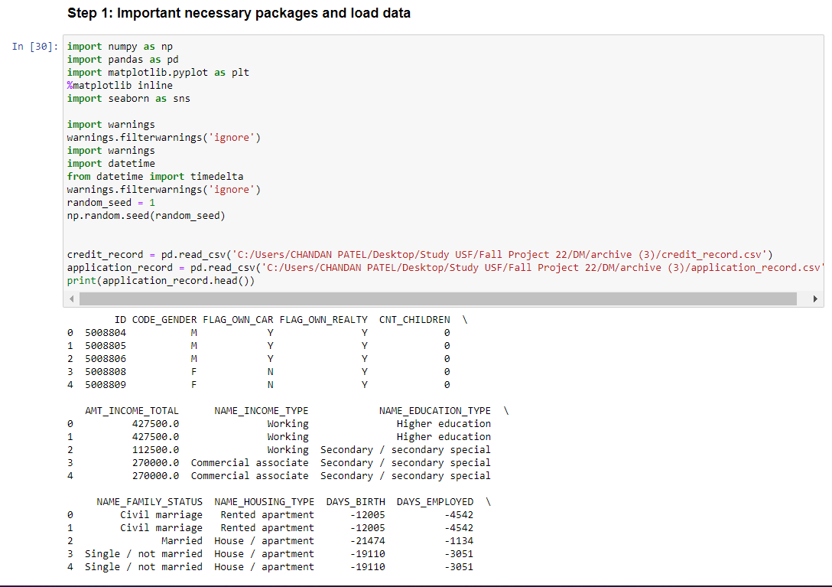

Once the files are imported and the packages are installed, we will start with our initial pre-processing of the data.

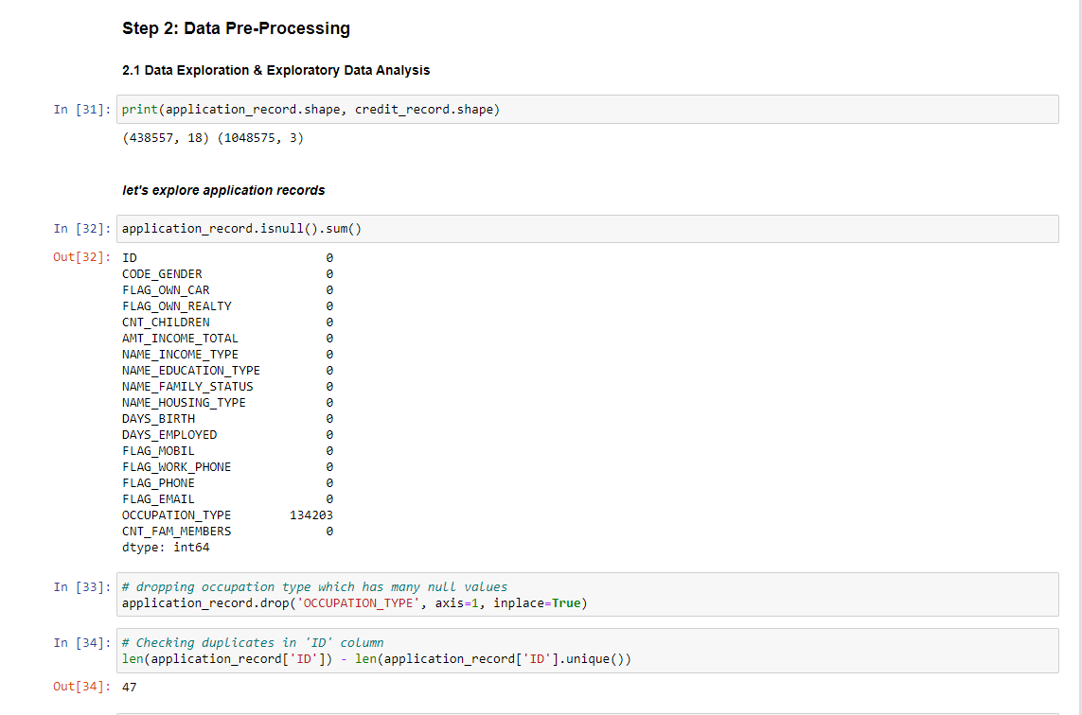

From the above screen capture, it can be seen that we are initially validating the null values and then dropping the occupation type record which contains many null values in it. Then we looked for the duplicate data in the ID column and dropped the duplicates.



Later we changed the DoB and record containing dates in the form of days to years for easier assessment.

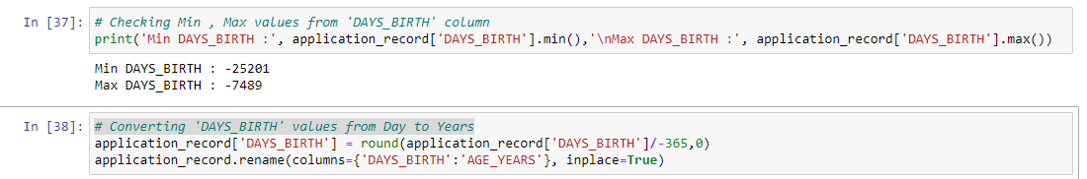

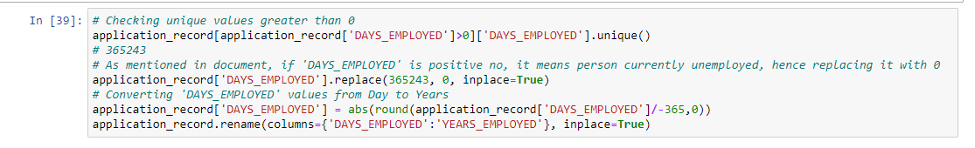

Also, notice all values in the FLAG_MOBIL are the same, hence dropping the column.

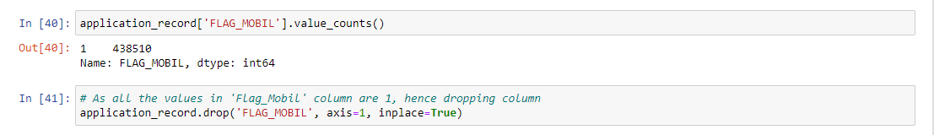

Now, we are done cleaning the IV dataset. Hence, we move forward by pre-processing the DV dataset, credit_record.csv. Firstly, we categorize the 'STATUS' column to binary classification where 0 means the client is **Eligible** and 1 means the client is **Not Eligible**.

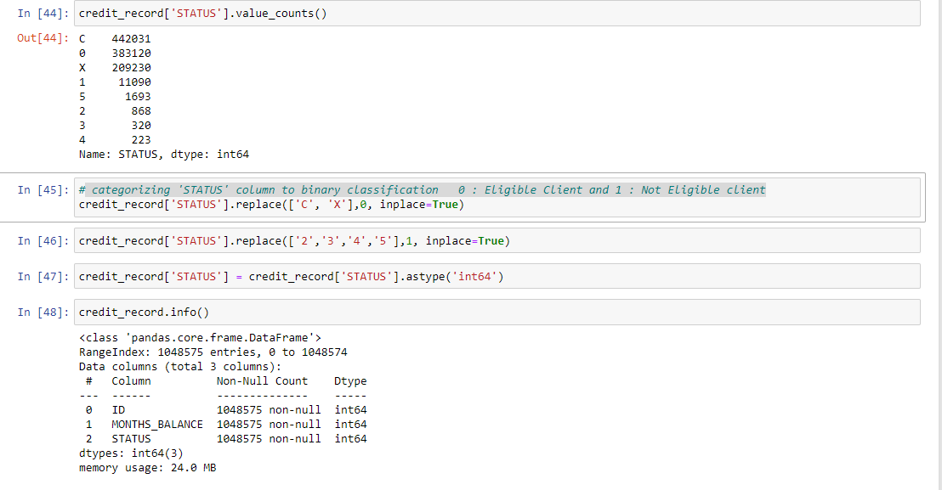

Later we merged both datasets.

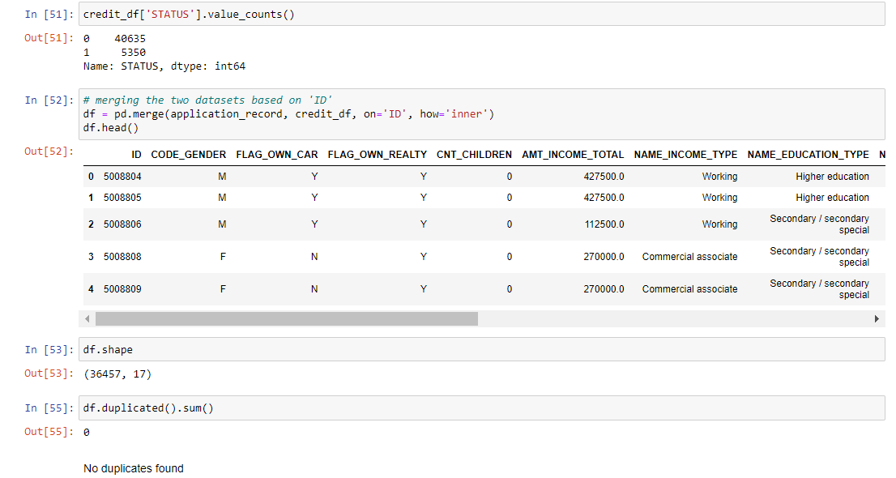

We have found it is best to drop the ID column as it has unique values and not of much value.



After doing Exploratory Data Analysis, we have found the below conclusion:

1. Majority of the applications submitted are by females.
2. Majority of the approved applications are of females.
3. Majority of the applicants don’t own a car.
4. Majority of the applicants own a properly/house.
5. Majority of the applicants don't have any children.
6. Majority of the applicant’s income lies between 100,000 to 300,000.
7. Majority of the applicants are working professional.
8. Majority of the applicants are married.
9. Majority of the applicants lives in House / Apartment.

We used sklearn package and used LabelEncoder for converting all the non-numeric columns to numeric ones, we were finally able to get the cleaned data file.

After complete pre-processing and we found that our dataset is imbalanced (Approx 85% of the data are eligible condition & 15% of the data are not eligible) as shown below.

We have addressed this issue in Azure ML (4th Point below) using SMOTE.

1. **Analysis of Credit Risk using Machine Learning:**

To make predictions about whether the consumer falls under the risk category or not by using different machine learning algorithms and selecting the best-performing model, we are choosing the Azure Machine Learning Studio to perform the operations.

Firstly, we have created a pipeline where the plan is to use the five best machine-learning algorithms to make predictions. To do so, we used the cleaned file. We know that the data is an imbalanced dataset. To deal with the imbalances, we have used **SMOTE**. SMOTE is used when the class that we are dealing with is unprecedented. It increases the number of cases in your dataset in a balanced way. The component works by generating new instances from existing minority cases that you supply as input. This implementation of SMOTE does not change the number of majority cases. The new instances are not just copies of existing minority cases. Instead, the algorithm takes samples of the feature space for each target class and its nearest neighbours. The algorithm then generates new examples that combine features of the target case with features of its neighbours. This approach increases the features available to each class and makes the samples more general. Below mention is the pipeline for our machine-learning model.

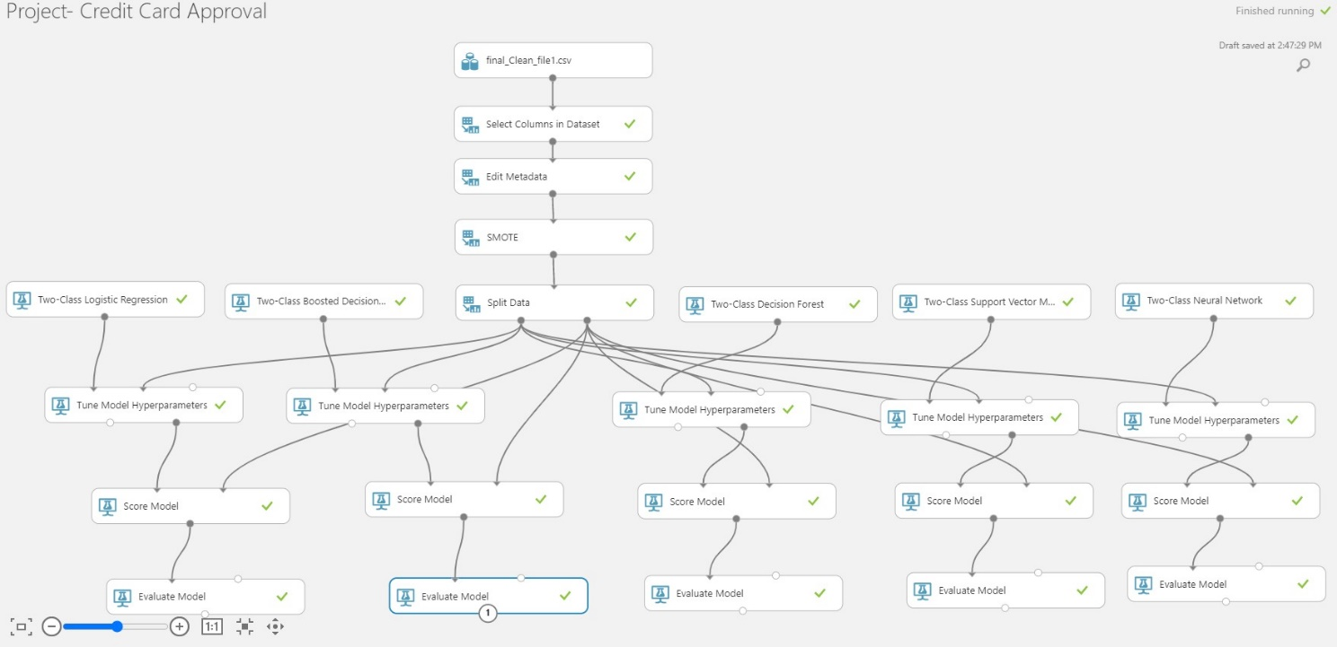

Splitting data:

The data was split into test and train. 70% is the train and the rest is a test. Then we applied the machine learning algorithms.

Tuning MODEL Hyperparameters:

We use hyper tunning module because it lets us control the model training process. For example, with neural networks, you can decide on the number of hidden layers and the number of nodes in each layer. Model performance depends heavily on hyperparameters. Hyperparameter tuning, also called hyperparameter optimization, is the process of finding the configuration of hyperparameters that results in the best performance. The process is typically computationally expensive and manual. Azure Machine Learning lets you automate hyperparameter tuning and run experiments in parallel to efficiently optimize hyperparameters.

1. **Methodology and Results**

We have used the below five Machine learning algorithms to make predictions:

1. Two-Class Logistic Regression
2. Two-Class Boosted Decision Tree Model
3. Two-Class Decision Forest
4. Two-Class Support Vector Machine Model
5. Two-Class Neural Network

We used Random sweep mode in the module and the Maximum number of runs on the random sweep was 5. We used this because we want to increase model performance by using the metrics of our choice and simultaneously conserve computing resources also.

The table below shows several measures for each model that was used to make predictions.

|  |  |  |  |  |  |
| --- | --- | --- | --- | --- | --- |
| Models | Accuracy | AUC | Precision | Recall | F1 Score |
| Logistic Regression | 0.633 | 0.693 | 0.65 | 0.618 | 0.636 |
| **Boosted Decision Tree** | **0.891** | **0.936** | **0.914** | **0.872** | **0.892** |
| Decision Forest | 0.822 | 0.896 | 0.896 | 0.773 | 0.818 |
| Support Vector Machine | 0.619 | 0.67 | 0.636 | 0.622 | 0.629 |
| Neural Network | 0.669 | 0.74 | 0.726 | 0.581 | 0.645 |

In our case as we know that the dataset was imbalanced so we can’t just rely only on the accuracy measures of the model. As per the business objectives, precision and recall measures are equally important for us for model comparison. So, we can see that Boosted Decision Tree Model from the above table is the best model for us, considering the values of the F1 Score which is nothing but the harmonic mean value of precision and recall.

**Conclusion**

To conclude, the business challenge of manually reviewing credit card applications has always been a major concern to management leaders in the banking domain. This process can be time error-prone and time-consuming. Obtaining a traditional credit card can take weeks. There are several steps that must be taken and checks that must be made, starting with the customer information being verified and ending with the real credit card approval. Since future clients' information and missing papers must be tracked, verified, and may arrive in various formats, these operations are typically manual and frequently not highly structured. This project proposes ML Models and analyses that can help the banks get through the hassle of enduring the technical / non-technical losses and the loss of time to both the customers and the banks so that the concentration is more towards the productive outcomes of both parties. A proper analysis is required as we see tremendous growth in the financial sector to avoid any kind of potential risk related to the unethical consumer. Also, this project to automate the process of identifying eligible customers who possess low risk while issuing credit cards can add a huge value to banking businesses.